**UNITY UNIVERSITY**

**DEPARTMENT OF COMPUTER SCIENCE**

1. ***WRITE YOUR:-***

***NAME________________________________***

***IDNO_________________________________***

***DEPARTMENT________________________***

***TIME ALLOWED:-2:30 hour***

1. ***INSTRUCTION:***
2. **DO NOT TURN THE PAGE UNTIL YOU ARE TOLD TO DO SO**
3. **SWITCH OFF YOUR CELL PHONES**
4. **MAKE SURE THAT THE EXAM BOOKLET CONTAINS 3 PARTS**
5. **USE ANSWERSHEET AND THE BLANK PAPER PROVIDED AT THE END OF THE LAST PAGE OF YOUR QUESTION PAPER**
6. ***FOR EVALUATION PURPOSE ONLY***

|  |  |  |  |
| --- | --- | --- | --- |
| ***CONTINIOUS ASSESSMENT*** | ***FINAL EXAM*** | ***TOTAL*** | ***GRADE*** |
|  |  |  |  |

***Part One:-Write “True” if the statement is correct and “False” if the statement is incorrect (1 points each)***

1. Relational modeling uses primary keys and foreign keys to maintain relationships between two or more entities.
2. Foreign keys are identifiers that enable a dependent relation (on the many side of a relationship) to refer to its parent relation (on the one side of the relationship).
3. Logical Database Design is the process of constructing a model of the informationused in an enterprise.
4. Attribute is real world physical or logical object with an independent existence and which is distinguishable from other objects.
5. Identifier attribute or Key is an attribute (or combination of attributes) that uniquely identifies individual instances of an entity type.
6. A derived attribute is an attribute whose value is calculated (derived) from other attributes.
7. The cardinality of a relationshipdescribes the mapping of associated entity instances in the relationship.
8. Connectivity expresses the minimum and maximum number of entity occurrences associatedwith one occurrence of the related entity.
9. An entity set that does not have a primary key is referred to as a weak entity set
10. An associative entity is an entity type that associates the instances of one or more entity types and contains attributes that are peculiar to the relationship between those entity instances.

***Part Two: - Choose the correct answer from the given alternatives and write the letter of your choice to the left of each question (1 point each)***

1. Which of the following are the building blocks of ***Relational Data model***?
2. Entities C. Attributes
3. Relationships D. Constraints

E. All of the above

1. Which of the following properties should be satisfied when the identifier of the entity type becomes the primary key of the corresponding relation?
2. The value of the key must uniquely identify every row in the relation
3. The key should serve as a foreign key in at least two other relations
4. The key must be a composite of a primary key and a secondary key
5. A and B
6. C and D
7. Which of the following ***is not*** associated with ***Database Design?*** 
   1. Structure the data in stable structures that are not likely to change over time and that have minimal redundancy.
   2. The preparation of a final conceptual model and the implementation of the database.
   3. Develop a logical database design from which we can do physical database design.
   4. Develop a logical database design that reflects the actual data requirements that exist in the forms and reports of an information system.
   5. None of the above
8. A binary ***one-to-many relationship in an E-R diagram*** is best represented by:
9. The creation of a separate relation; the primary key of this new relation is a composite key consisting of the primary key for each of the two entities in the relationship
10. Adding the primary key attribute (or attributes) of the entity on the one side of the relationship as a foreign key in the relation that is on the many side of the relationship
11. Adding the primary key attribute (or attributes) of the entity on the many side of the relationship as a foreign key in the relation that is on the one side of the relationship
12. Creating a relation with a composite primary key and non-key attributes
13. None of the above
14. Which of the following activities are expected to be performed in the ***Conceptual design phase of database design***?
15. Construct the organizational and user data requirements discovered and analyzed during requirement analysis
16. Identify all entities and their relationships
17. Define entity attributes and constraints
18. All of the above
19. None of the above
20. The following are the advantages of conceptual database design ***except one***?
21. Helps users and system developers to identify data requirements (abstract model)
22. Allows for easy communication between end-users and developers.
23. It is dependent of DBMS or any Operating Systems
24. It is a permanent description of the database requirements
25. None of the above
26. Which of the following database model is the best to design the conceptual database design phase?

A) Relational Database Model C) Entity-Relationship Diagram

B) Network Database Model D) Object-Oriented Database Model

E) None of the above

1. The following statements best describes about Entity ***except one***?
2. Each entity occurrences in ER Diagram is not unique and distinct
3. An entity represents a particular type of real world, physical or logical object
4. It is anything (a person, a place, a thing, or an event) about which data to be collected and stored
5. The name of an entity is a noun, written in capital letters and is written in singular form
6. None of the above
7. Which of the following is true about ***Entity-Relationship-Diagram (ERD)*** data model?

A. It is a model used to represent entities attributes, relationships and constraints

B. It models all the building blocks of the database graphically

C. It models an abstract and conceptual representation of data

D. All of the above

E. None of the above

10. Which of the following building blocks of the database will give rise to recorded items of data in the database or used to store data in a database?

* + 1. Entities C. Relationships
    2. Attributes D. Business Rules

E. None of the above

11. Observe the following ER-Diagram and identify which of the following attributes are used as ***multivalued attribute and derived attribute respectively?***

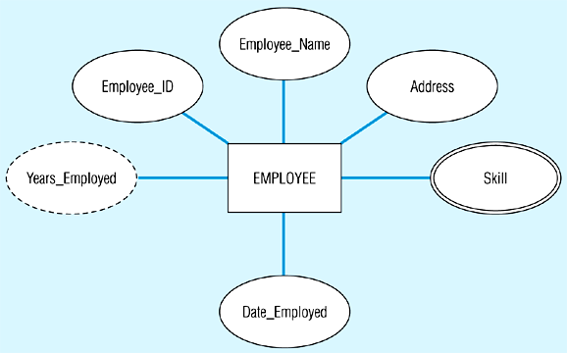

1. Address and Skill C. Skill and Years-Employed
2. Years-Employed and Skill D. Employee_ID and Skill

E. None of the above

12. Which of the following attribute (or combination of attributes) that uniquely identifies individual instances of an entity type?

1. Identifier(primary key) attribute C. Derived attribute
2. Multivalued attribute D. Stored attribute

E. Required attribute

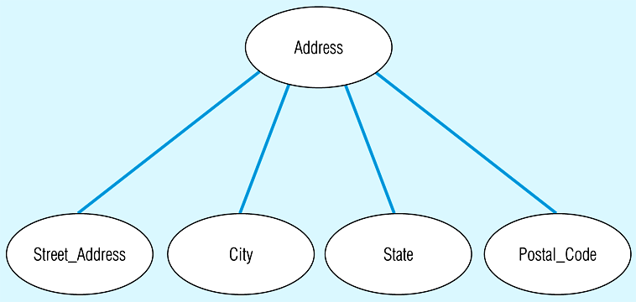13. Observe the following ER-Diagram that indicates only attributes, what types of attributes are indicated in this diagram?

1. Simple attribute C. Derived attribute
2. Composite attribute D. Stored attribute

E. Required attribute

14. Derived attribute need not be physically stored within the database; instead, it can be derived by using an algorithm. The following is some of the ***limitations*** of derived attributes ***except one***?

1. It save storage space
2. Requires much CPU processing cycles
3. It increases data access time
4. Adds coding complexity to queries
5. None of the above
6. 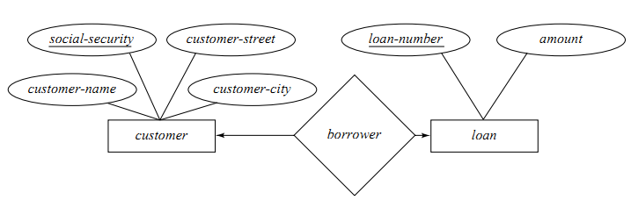Observe the following ***ER-Diagram***, what type of relationship is existed between CUSTOMER and LOAN entities?

1. One-to-Many (1:N) C. Binary Relationships
2. One-to-One (1:1) D. Many-to-Many(M:N)

E. All except A and D

16. Which of the following statement ***is true*** about Associative Entity?

A. The associative entity should have at least one or more attributes other than the identifier.

B. An associative entity is an entity type that associates the instances of one or more entity types and contains attributes that are peculiar to the relationship between those entity instances

C. The associative entity may participate in other relationships other than the entities of the associated relationship.

D. All of the above E. None of the above

17. The most common style for a ***Logical Database design*** is the:

A) Relational Database Model C) Hierarchical Database Model

B) Network Database Model D) Object-Oriented Database Model

E) None of the above

18. All but one of the following statements ***is true*** about relational database model

1. A relation is a named, two-dimensional table of data
2. A relation (in relational database) is the same as a relationship (in E-R model)
3. Relational modeling uses primary keys and foreign keys to maintain relationships
4. The objectives of logical database design is to translate the conceptual design into a logical database designthat can be implemented on a chosen DBMS
5. All of the above

19. Which of the following activities are expected to be performed in the Conceptual design phase of database design?

1. Constructing a model of the informationused in an enterprise and describe the data requirements including detailed descriptions of the entity types, relationships, and constraints
2. Reﬁne the database design to ensure that it meets desired performance criteria.
3. Defines specific internal storage structures or access methods used by database, file organizations, indexes, and physical design parameters for the database files specified.
4. All of the above E) None of the above

20. All of the following are true about ***Logical Database design*** ***except one***:

1. Data normalization is a logical database design technique
2. Conversion of E-R diagrams to relational tables is a logical database design technique
3. Logical Database design is performed before Physical Database design
4. Physical Database design is performed before Logical Database design
5. The tables that result from logical database design have no data redundancy

***Part Three: - Read the following business definitions carefully and answer the required questions (20 points)***

Top Fashion is a mail order company specialized in supplying men’s and women’s quality fashion clothing. Manufacturers and textile importers throughout Addis Supply the items of clothing for Top fashion, just one manufacturer or importer supplier each item, but most manufacturers and importers supply many different items of clothing. The company maintains data about factory address and manager’s name for factories and importers, respectively. It also maintains supplier’s code and store address in both cases. Each item is allocated a unique code by the company. Customers send orders to the company; each order can be for one several items. The mail order company orders stock from the manufacturers and importers using a clothing requisition. A clothing requisition can be for one or many items of clothing.

The company stores the following information about each customer order that it receives: a unique customer order number, the date the order is received, the customer’s unique number, the customer’s name, address and telephone number, the unique code for each item ordered and its description and price, and the quantity ordered. It also maintains the following information about each clothing requisition it sends to suppliers: a unique requisition number, the date the requisition is sent, the supplier’s unique number, the supplier’s name, store address and telephone number, the unique code for each item ordered and its description, quantity and price.

Based on the above Business definition, answer the following questions:

1. Identify entities and attributes necessary for this business model
2. Draw the ER-Diagram and show all the relationships in the diagram
3. Map the ER-Diagram in to Relational Model

***NAME_________________________IDNO_______________________***

***ANSWERSHEE***

***PART ONE PART TWO***

1. __________ 1. __________ 11. _________
2. __________ 2. __________ 12. _________
3. __________ 3. __________ 13. _________
4. __________ 4. __________ 14. _________
5. __________ 5. __________ 15. _________
6. __________ 6. __________ 16. _________
7. __________ 7. __________ 17. _________
8. __________ 8. __________ 18. _________
9. __________ 9. __________ 19. _________
10. __________ 10. _________ 20. _________